Spreadsheet Chart Assignment

- Create the following spreadsheet with proper formatting (Save as classperiod_lastname_firstname_gasprices in your Spreadsheets Folder):
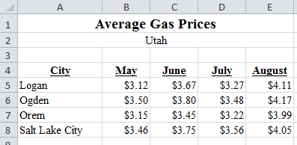
Chart #1 Clustered Column Chart
- Create a cluster column chart (you will need to select A4:E8 and then insert the chart) with these specifications:
  - Title: Regional Gas Prices
  - X-Axis Title: Month
  - Y-Axis Title: Price Per Gallon
- Move the chart so that it is on a new sheet.
- Insert a footer with your name, Chart 1 and class period.

Chart # 2 Line Chart with Markers
- Click on Sheet1 to return to spreadsheet.
- Create a line chart with markers that compares Logan and Salt Lake City for the four-month period. You will need to select A4:E5 then hold down the ctrl key and select A8:E8 then release ctrl and the mouse button.
- Use the following Specifications:
  - Title: Comparison - Logan & Salt Lake City.
  - X-Axis Title: Month
  - Y-Axis Title: Price Per Gallon
  - Legend: Positioned as an Overlay on the right
  - Move the chart so that it is on a new sheet.
  - Insert a footer with your name, Chart 2 and class period.

Chart #3 Line Chart with Markers
- Click on Sheet 1 to return to spreadsheet.
- Create a line chart with markers that compares all 4 cities.
- Select A4:E8 and then insert a line chart (make sure to include markers).
- Use the following specifications:
  - Title: Utah City Gas Comparison
  - X-Axis: Month
  - Y-Axis: Price Per Gallon
  - Legend: Overlay on the right.
- Do NOT move to a new sheet. Click the Chart and drag so it is positioned right below the spreadsheet. You should be able to see both the Chart and the Spreadsheet easily. Make sure it fits to one page.
- Create a footer with your name, Chart #3 and class period.

