Special K

Directions: The **k** sound can be spelled **c, k, ch,** or **ck**. The word for each picture below has a **k sound**. Write a separate sentence for each of the words. Make sure to use the numbering feature and bold the word in the sentence.

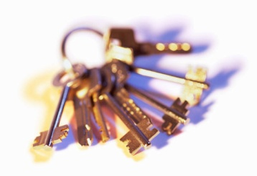

____________________ ______________ ________________________

 C:\Documents and Settings\mrevoir\Local Settings\Temporary Internet Files\Content.IE5\UJAJI5IB\MC900215172[1].wmf

C:\Documents and Settings\mrevoir\Local Settings\Temporary Internet Files\Content.IE5\UJAJI5IB\MC900024365[1].wmf____________________ ________________ ________________________



  



  